LAB # 07

Modeling Frequency Division Multiplexing/DE-multiplexing



CSE-402L DIGITAL SIGNAL PROCESSING LAB

Name: Maaz Habib

Reg No: 20PWCSE1952

Section: C

“On my honor, as student of University of Engineering and Technology, I have neither given nor received unauthorized assistance on this academic work.”

Department of Computer Systems Engineering

University of Engineering and Technology, Peshawar

**Title: Implementing Frequency Division Multiplexing/De multiplexing using Matlab**

**Objective:**

Implement the following steps in Matlab to Multiplex three input voice signals at the transmitter end and Demultiplex and play them back at the Receiver end. Add random noise to the signal while propagating via the channel.

**STEP 1:**

The signals are reproduced as they arrive

**Code:**

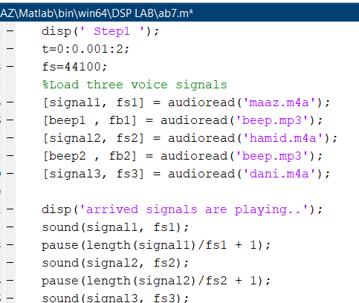

**STEP 2**

Plot the spectra of the signals as they arrive (Use fft and dsp.SpectrumAnalyzer  for

comparison)

**Code**

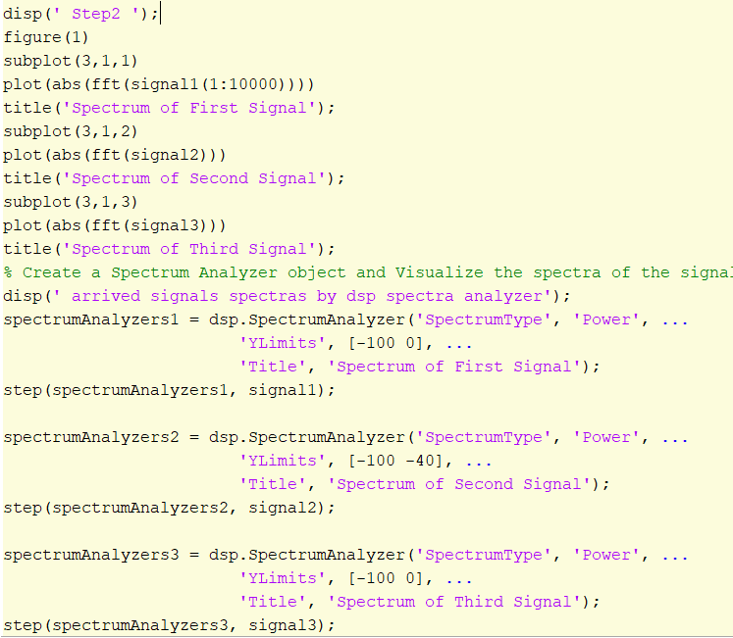

**Output:**

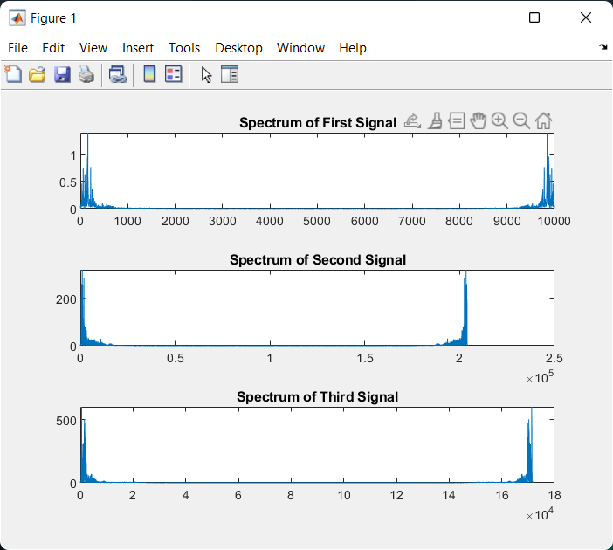

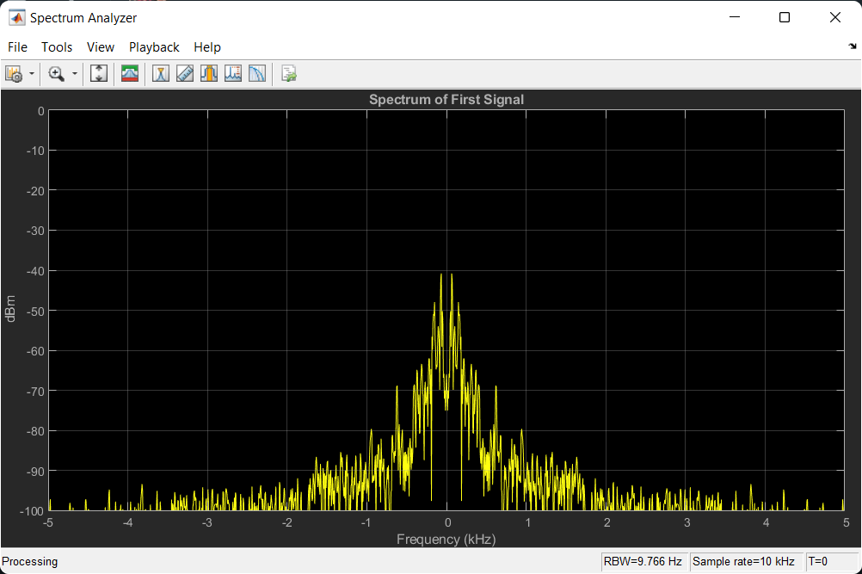

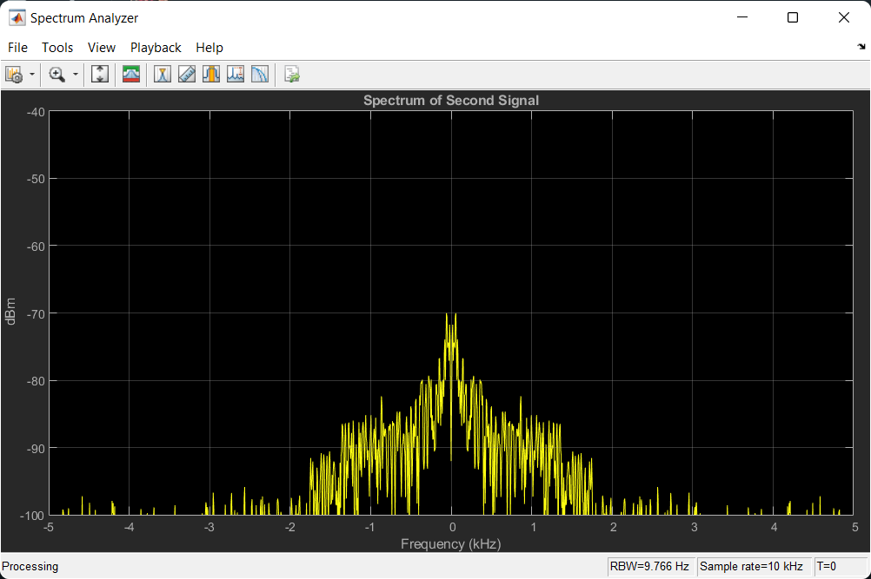

**STEP 3**

The signals are passed through a low pass filter and plotted

**Code**

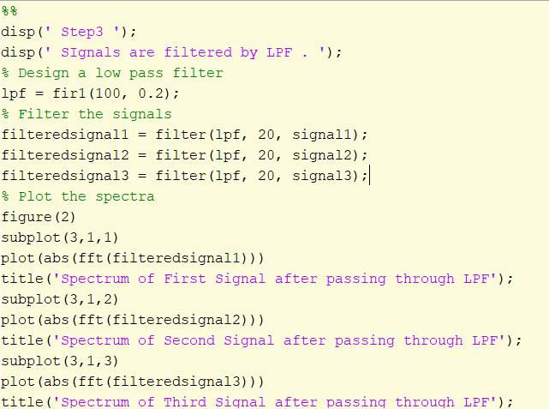

**Output**

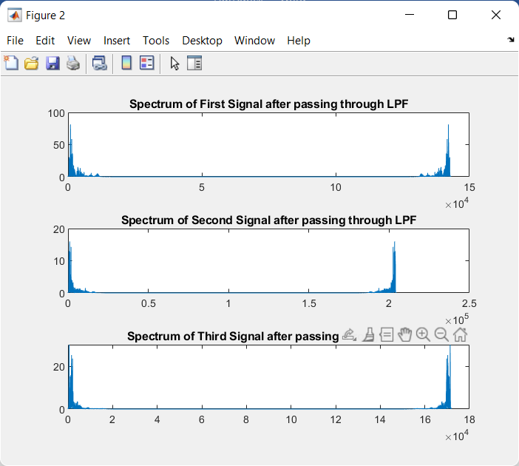

**STEP 4**

Reproduce the signals after passing them through the filter

**Code**

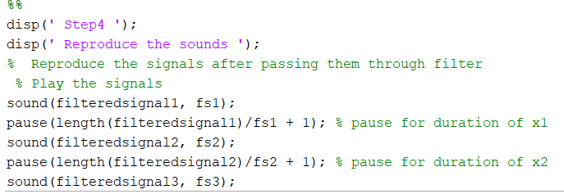

**STEP 5**

The signals are modulated to different carriers

**Code**

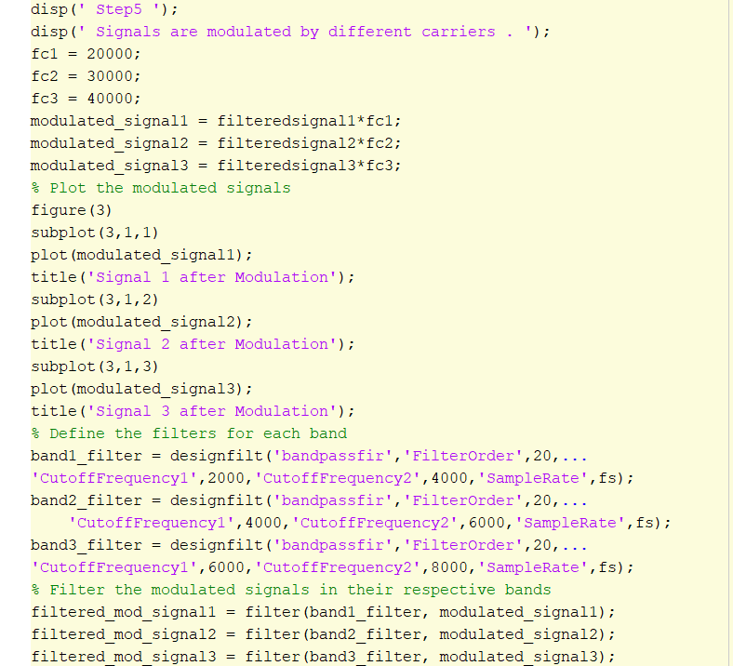

**Output**

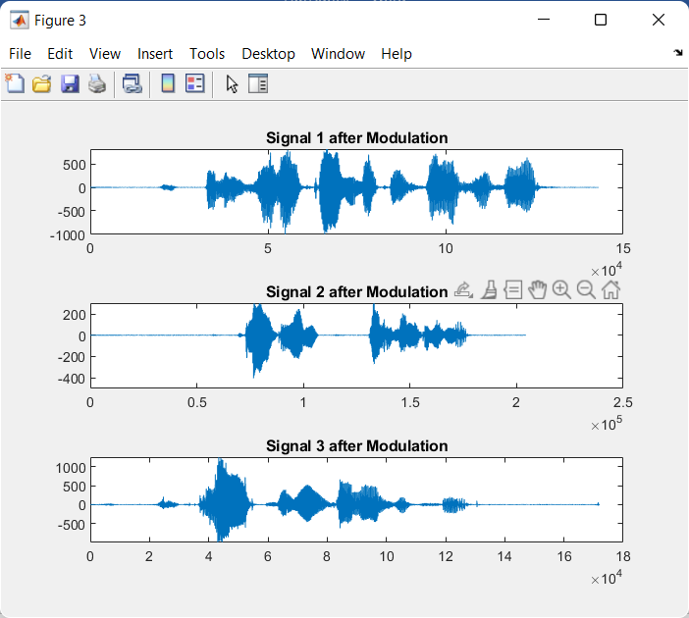

**STEP 6**

The modulated signals are filtered in the given band and added together

Multiplexed Signal

**Code**



**Output**

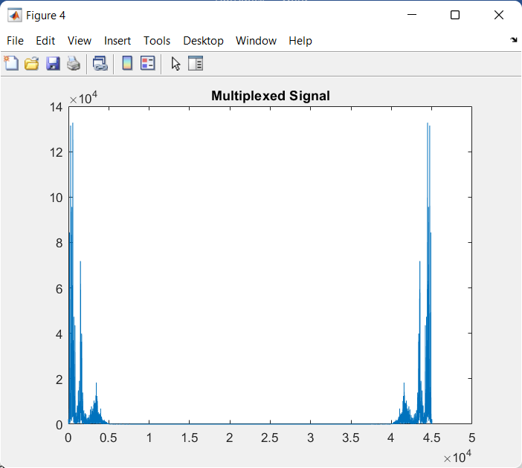

**STEP 7**

Some noise is added to the transmitted signal

Channel Effect, adding noise

**Code**

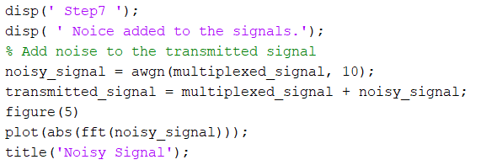

**Output**

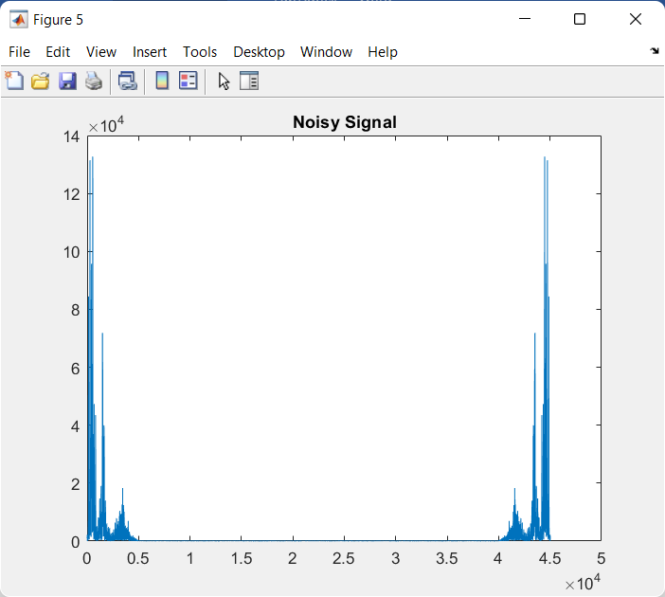

**STEP 8**

Upon arrival each band is filtered

**Code**

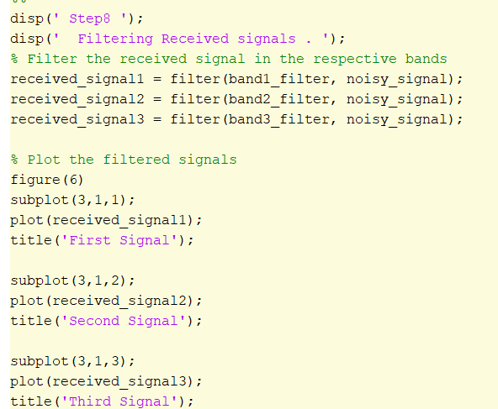

Output:

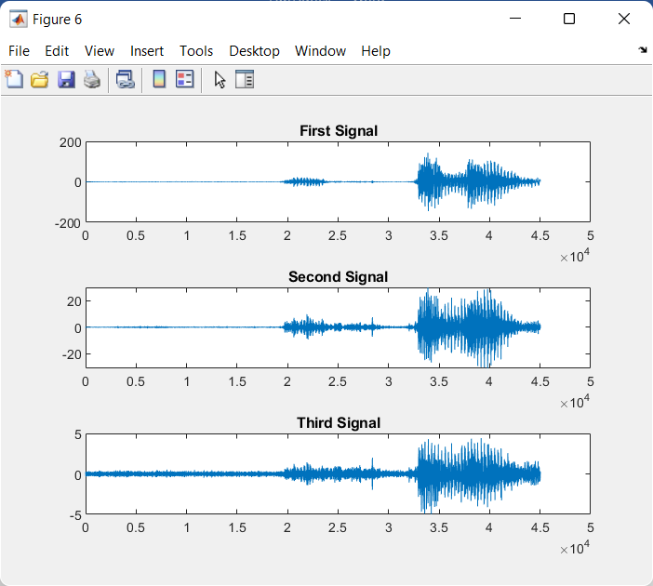

**STEP 9**

Each recovered band is demodulated to return the signal at the indicated frequency

**Code**

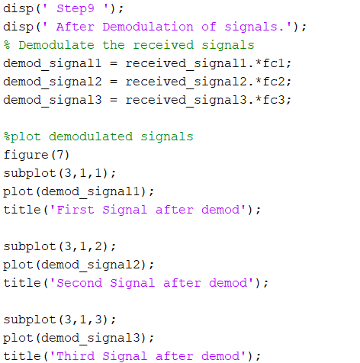

Output:

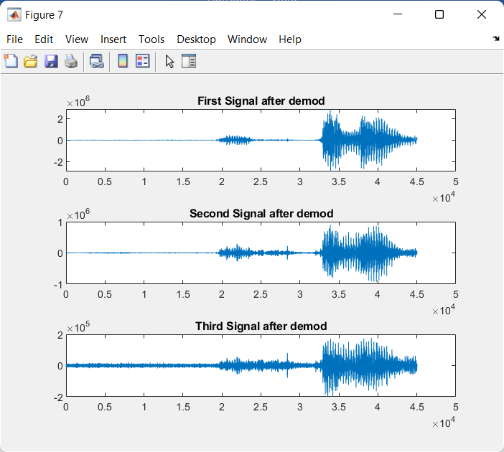

**STEP 10**

The recovered signal is passed through a low pass filter

**Code**

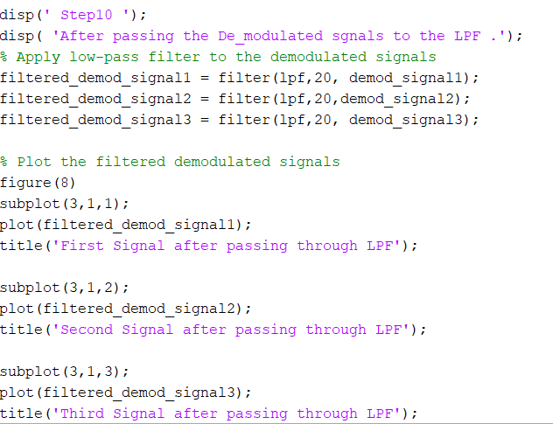

**Output:**

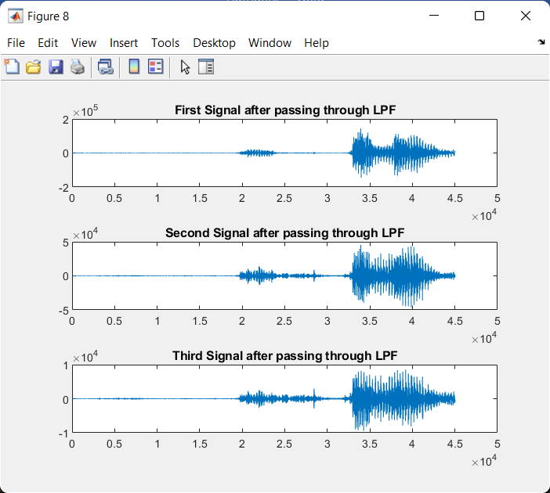

**STEPS 11**

Signal reproduced after transmission

**Code**

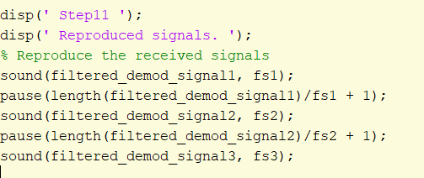

**Conclusion**

In this lab first we recorded three voices (all are male voices). Then we plot the spectrums of these signals. Then we pass these voices through a low pass filter. Then we filtra it and plot these voices. Then we modulate these signals and plot their spectrums. After modulation we add these signals to get a multiplexed signal. Then we add this multiplexed signal with noise signal. We take a random voice signal. Then we pass this signal through a filter then we demodulate this signal to recover our original signals.